世界5大餐饮秘方解秘

【摘要】这些东西只要有配料，就很容易做出来。中餐就是把配料全部给你准备齐了，你也不见得抄得出那个味道来，这叫功夫！

肯德基原味鸡制作秘方
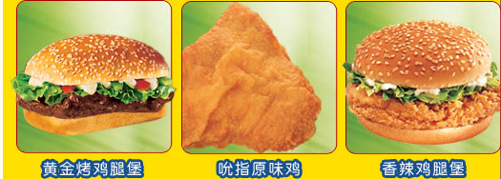
中文版
官方的配方:
2杯面粉，
1/2茶匙食盐，
1/2茶匙百里香叶，
1/2茶匙罗勒，
1/2茶匙oregano（唇形科植物），
1 汤匙芹菜味的盐，
1 汤匙黑胡椒，
1 汤匙干燥的芥末，
4 汤匙甜椒粉，
2茶匙蒜盐，
1茶匙生姜，
3 汤匙的味精（个人建议用鸡精）
做法
1。在一个大碗混合所有的ingrediants。
2。把鸡块蘸入打碎的鸡蛋 （在上面介绍过）
3。把它们在面包渣里翻转，使之两面都蘸上面包渣
4。最后把鸡块放进上面1中的混合物。
5。把烤箱升温到350度（个人建议用pressure cooker，肯德基店里就用的这个)
6，把鸡块放在一个铁质托盘里，上面盖上锡纸（闪光的那面朝外）
7。加热40分钟。
8。拿掉锡纸，再做40分钟
9。出锅前5分钟往鸡块上淋一点油
10。出锅后，凉5分钟，再食用。
英文版：
this is the official recipe!!!!!
2 cups of flour,
1/2 tsp salt,
1/2 tsp thyme,
1/2 tsp basil,
1/2 tsp oregano,
1 tbsp celery salt,
1 tbsp black pepper,
1 tbsp dry mustard,
4 tbsp paprika,
2 tsp garlic salt
1 tsp ground ginger,
mix all ingrediants in a large bowl.
dip chicken pieces in beaten eggs,
then turn them over in regular bread crumbs, (commercial)
finally plunge them into the above mix.
heat oven to 350 degrees
place chicken in a tray and cover with foil. (shiny side out)
cook 40 minutes.
remove foil and cook for another 40 minutes.
baste lightly with oil 5 minutes before the end,
let stand 5 minutes and serve.
麦当劳“big mac”汉堡配方
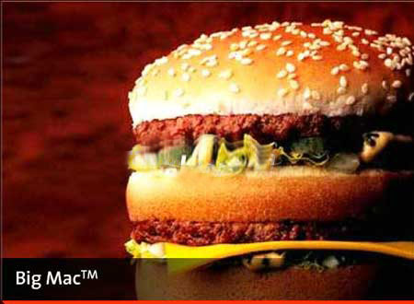
原料：
1 带芝麻的甜面包
1 正常的甜面包
2 提前冻的牛肉小馅饼
2 汤匙的big mac 酱汁（方法写在下面）
2 茶匙洋葱
1 片美国干酪
2 汉堡蔬菜薄片
1/4 杯撕碎的冰山莴苣
制作:
保留甜面包带芝麻的一半。 big mac的做法跟一般汉堡是基本相同的，仅仅是面包的烤制方法有点不同。做的时候，先把带芝麻的甜面包的底部烤热（切下的那部分，不带芝麻），与此同时，再烤一块正常面包的底部（作为中间那层）
就象做正常的汉堡那样做的two－all－beef－patties，（煎制）
在甜面包烤完以后， 把1大汤匙的“big mac酱汁”抹在面包上被烤得那面
然后每片加上1/8杯撕碎了的莴苣。
在甜面包剩下的底部， 在莴苣上的加薄薄的一片美国的干酪。
在中间那层上加2片蔬菜。
带芝麻的顶部也需要烤。
当牛肉小饼做好时，把它们放在面包的底部和中部（一片）。
最后，盖上顶层的面包片。
最后在微波炉高温加热15秒即可（包在蜡纸里加热）。
附：big mac 酱汁的做法
原料：
1 杯甜奶油
1/2 杯甜玉米调味酱
1/3 杯桔色的法国kraft creamy dressing
1 汤匙糖
1/4 茶匙黑胡椒
1 茶匙干燥的碎洋葱
一起搅动并且冷却。
英文原版：
mcdonalds big mac
ingredients:
6park.com
amount measure ingredient －－ preparation method
－－－－－－－－ －－－－－－－－－－－－ －
1 regular sized sesame seed bun
1 regular sized plain bun
2 previously frozen regular beef patties
2 tablespoons big mac sauce
2 teaspoons reconstituted onions
1 slice real american cheese
2 hamburger pickle slices
1/4 cup shredded iceberg lettuce
preparation:
discard the crown half of the regular bun, retaining the heel. the cooking method for the big mac™ is basically the same as the regular burgers, only the bun toasting method is slightly different. in the big mac s case you toast the bottom (heel) first. do this along with the extra heel (this will be your middle bun.).
cook the two－all－beef－patties just like the regular burgers.
after the bun parts are toasted, put 1 tablespoon of mac sauce on each of the heels (toasted side).
then add 1/8 cup shredded lettuce to each.
on the true bottom bun, place one thin slice of american cheese on top of the lettuce.
on the extra heel, the middle bun, place two pickle slices on top of the lettuce.
toast the crown (top) of the bun also.
when the meat patties are done, place them one at a time on both prepared buns.
stack the middle bun on top of the bottom bun, and put the crown on top
microwaved, still wrapped, 15 seconds on high.
mcdonald s big mac sauce
amount measure ingredient －－ preparation method
－－－－－－－－ －－－－－－－－－－－－ －－－－－－－
1 cup miracle whip
1/2 cup relish
1/3 cup kraft creamy french dressing －－ (orange not red 6park.com
kind
1 tablespoon sugar
1/4 teaspoon black pepper
1 teaspoon dry minced onion
stir together and chill.
必胜客pizza配制秘方
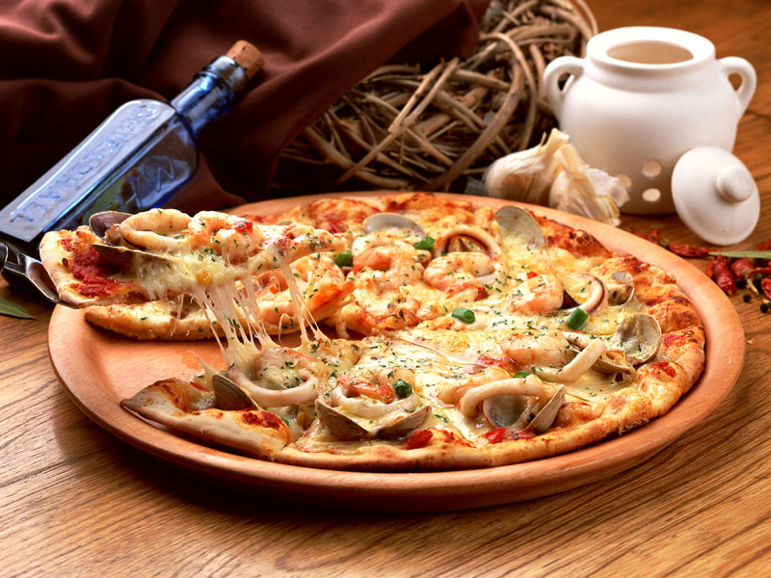
中文版
原料：
2 罐冷藏的比萨面团
1/2－3/4 杯碎莫泽雷勒干酪（分散使用)
3/4 杯撕碎了的monterey jack（不知道是什么， 知道得说一声）
3/4 杯碎切达干酪
3/4 杯碎provolone（有知道得告诉我）
2 汤匙碎帕尔马干酪
2 汤匙碎romano
你可选择的顶层加料(pepperoni，铃辣椒， 橄榄， 等等。)
1 罐比萨酱汁
方法步骤：
把烤箱预先加热到475f。
在撒了薄薄的一层面粉的面板表面，用蘸有面粉的擀面杖擀开面团使之成为1/4英寸厚的饼 。 把面饼放在一个提前抹了油的有孔的平底锅（12 英寸）。 用小刀将饼弄成在平底锅的直径内适合的整齐面团。 然后，在每半英寸面团用叉子刺透来阻止气泡 (这将最终是你的顶部酥皮)。
先把这个酥皮提前在烤箱里烘烤5分钟，从平底锅一开这个外壳酥皮，然后把它放在有网的盘碟加上冷却。
用一样的方法为平底锅准备第二外壳酥皮， 但是用转动的面棒移除平底锅边缘上多余的面渣。 用叉子刺透。 把3/4杯莫泽雷勒干酪和其余的干酪匀称地萨在这层外壳上，然后把第一层酥皮放在他们上面。
把比萨酱汁（1/2杯）匀称的撒在第一层酥皮上， 然后散上你的选择的顶层加料， 以肉开始， 然后蔬菜。 最后加2杯莫泽雷勒干酪。
烘烤12～15分钟， 或者到干酪完全溶化并且呈金褐色为止。
英文原版
ingredients
2 cans refrigerated pizza dough
2－3/4 cups shredded mozzarella (divided use)
3/4 cup shredded monterey jack
3/4 cup shredded cheddar
3/4 cup shredded provolone
2 tablespoons grated parmesan
2 tablespoons grated romano
toppings of your choice (pepperoni, bell peppers, olives, etc.)
1 jar pizza sauce
包含uctions
preheat oven to 475 degrees f.
on a lightly floured surface, unroll first pizza dough. using a rolling pin dusted with flour, roll dough to 1/4－inch thickness. place in a well－greased 12－inch perforated pizza pan. trim dough with a knife or pizza wheel to fit inside the diameter of the pan. pierce dough with a fork every half－inch to prevent air bubbles. (this will ultimately be your top crust.)
prebake this crust for 5 minutes; remove crust from pan and place on a wire rack to cool.
prepare the second crust for the pan in the same way, but remove the excess dough around the edges by rolling a rolling pin over the top of the pan to form a lip on the crust. pierce with a fork. combine 3/4 cup mozzarella and remaining cheeses and spread evenly over this crust. put the partially baked crust on top of the cheese layer.
spread 1/2 cup of pizza sauce over this top crust, then scatter the toppings of your choice, starting with meats, then vegetables. finish with the final 2 cups of mozzarella.
bake for 12 to 15 minutes, or until the cheese is melted and golden brown.
百事可乐配置秘方
可乐树规则:
糖 标准confectioners－a7500磅
水 足够的数量最多1200加仑
焦糖（烧焦的糖色） 12加伦
酸橙汁 12加伦
磷酸s.g。1.750 58磅
白酒 1/2加伦
油柠檬 6液体盎司
油橘子 5液体盎司
肉桂油 4液体盎司
油肉豆寇 2液体盎司
油香菜 2液体盎司
可乐树油谷物 1液体的盎司
混合，煮沸糖和水，与此同时搅动2个小时
英文版
pepsi cola formula:
sugar－ standard confectioners a 7500 pounds
water, sufficient quantity to 1200 gallons
caramel － burnt sugar color 12 gallons
lime juice 12 gallons
phosphoric acid s.g. 1.750 58 pounds
alcohol 1/2 gallon
oil lemon 6 fluid ounces
oil orange 5 fluid ounces
cinnamon oil 4 fluid ounces
oil nutmeg 2 fluid ounces
oil coriander 2 fluid ounces
oil petit grain 1 fluid ounce
mix; stir two hours:
boil sugar and water
可口可乐的配置秘方

中文版
原料
1 盎司滤后咖啡因
3 盎司柠檬酸
1 盎司香草醛
1.14 升酸橙汁
2.5 盎司的调味料（见下）
30 磅糖
4 盎司可可豆
2.5 扎水
足够的焦糖
调味料
80 oil（个人认为是计量单位，有知道得告诉我） 橘子
40 oil 肉桂
120 oil 柠檬
20 oil 香菜
40 oil 肉豆蔻
40 oil neroli(知道的告诉我哈）
1.14 升酒精（酒）
方法
把咖啡因酸和酸橙汁混合成1.14升。把水煮沸并且加入香草醛，等到凉了以后，加入调味剂。搅拌后，放置24小时候即可饮用
英文原版
ingredients
2 cans refrigerated pizza dough
2－3/4 cups shredded mozzarella (divided use)
3/4 cup shredded monterey jack
3/4 cup shredded cheddar
3/4 cup shredded provolone
2 tablespoons grated parmesan
2 tablespoons grated romano
toppings of your choice (pepperoni, bell peppers, olives, etc.)
1 jar pizza sauce
包含uctions
preheat oven to 475 degrees f.
on a lightly floured surface, unroll first pizza dough. using a rolling pin dusted with flour, roll dough to 1/4－inch thickness. place in a well－greased 12－inch perforated pizza pan. trim dough with a knife or pizza wheel to fit inside the diameter of the pan. pierce dough with a fork every half－inch to prevent air bubbles. (this will ultimately be your top crust.)
prebake this crust for 5 minutes; remove crust from pan and place on a wire rack to cool.
prepare the second crust for the pan in the same way, but remove the excess dough around the edges by rolling a rolling pin over the top of the pan to form a lip on the crust. pierce with a fork. combine 3/4 cup mozzarella and remaining cheeses and spread evenly over this crust. put the partially baked crust on top of the cheese layer.
spread 1/2 cup of pizza sauce over this top crust, then scatter the toppings of your choice, starting with meats, then vegetables. finish with the final 2 cups of mozzarella.
bake for 12 to 15 minutes, or until the cheese is melted and golden brown.
百事可乐配置秘方
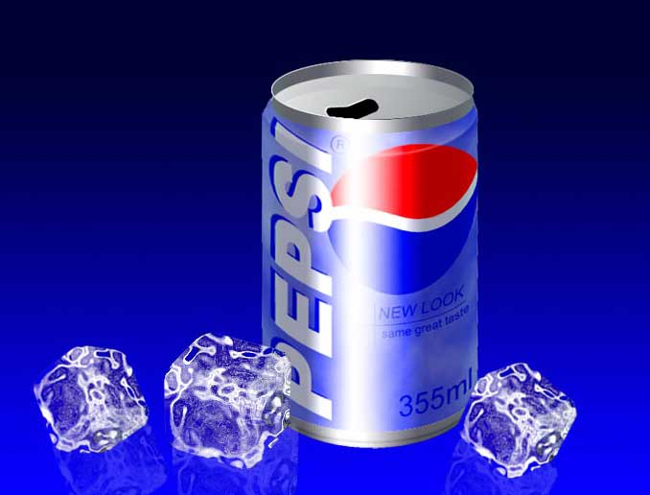
中文版
可乐树规则:
糖 标准confectioners－a7500磅
水 足够的数量最多1200加仑
焦糖（烧焦的糖色） 12加伦
酸橙汁 12加伦
磷酸s.g。1.750 58磅
白酒 1/2加伦
油柠檬 6液体盎司
油橘子 5液体盎司
肉桂油 4液体盎司
油肉豆寇 2液体盎司
油香菜 2液体盎司
可乐树油谷物 1液体的盎司
混合，煮沸糖和水，与此同时搅动2个小时
英文版
pepsi cola formula:
sugar－ standard confectioners a 7500 pounds
water, sufficient quantity to 1200 gallons
caramel － burnt sugar color 12 gallons
lime juice 12 gallons
phosphoric acid s.g. 1.750 58 pounds
alcohol 1/2 gallon
oil lemon 6 fluid ounces
oil orange 5 fluid ounces
cinnamon oil 4 fluid ounces
oil nutmeg 2 fluid ounces
oil coriander 2 fluid ounces
oil petit grain 1 fluid ounce
mix; stir two hours:
boil sugar and water

[全文完]

